CSA1566-CLOUD COMPUTING AND BIG DATA ANALYTICS FOR GENERIC APPLICATIONS

Name: Krishna Subramanian

Reg no: 192211042

Lab Record

Exp 1

Flight reservation system

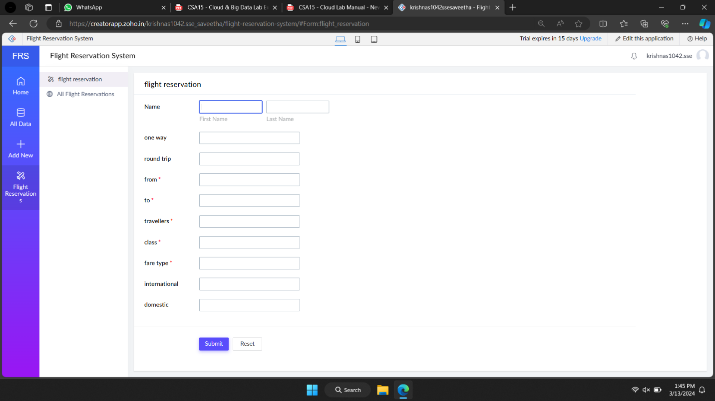

Steps:

* Sign up for a Cloud Service Provider:
* Create a New Application Environment:
* Design Your Application:
* Main Dashboard
* Flight Search and Booking
* Type of trip (one-way or round trip).
* Departure and destination airports.
* Departure date and return date (for round trips).
* Number of travellers.
* Class selection (economy, business, first class, etc.).
* Fare type (standard, discounted, etc.).
* Booking Confirmation
* Payment Integration
* Set Up Database:
* Implement Business Logic
* Deployment:

Exp 2

Buy and rent

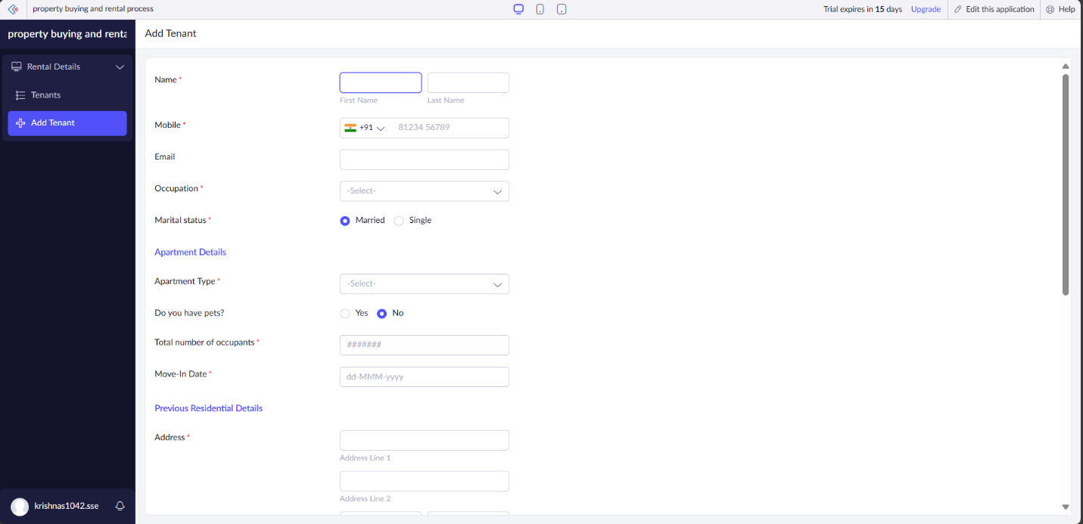

Steps:

* Sign up for a Cloud Service Provider
* Create a New Application Environment
* User Authentication
* Main Dashboard
* Property Listings
* Property Details
* Type of transaction (buy or rent).
* Property type (residential or commercial).
* Rental agreement terms (if applicable).
* Area and location details (neighbourhood, city, etc.).
* Price range or property value.
* Search and Filter Options
* Rental Agreement Management
* Set Up Database
* Implement Business Logic
* Deployment

Exp 3

Car booking reservation system

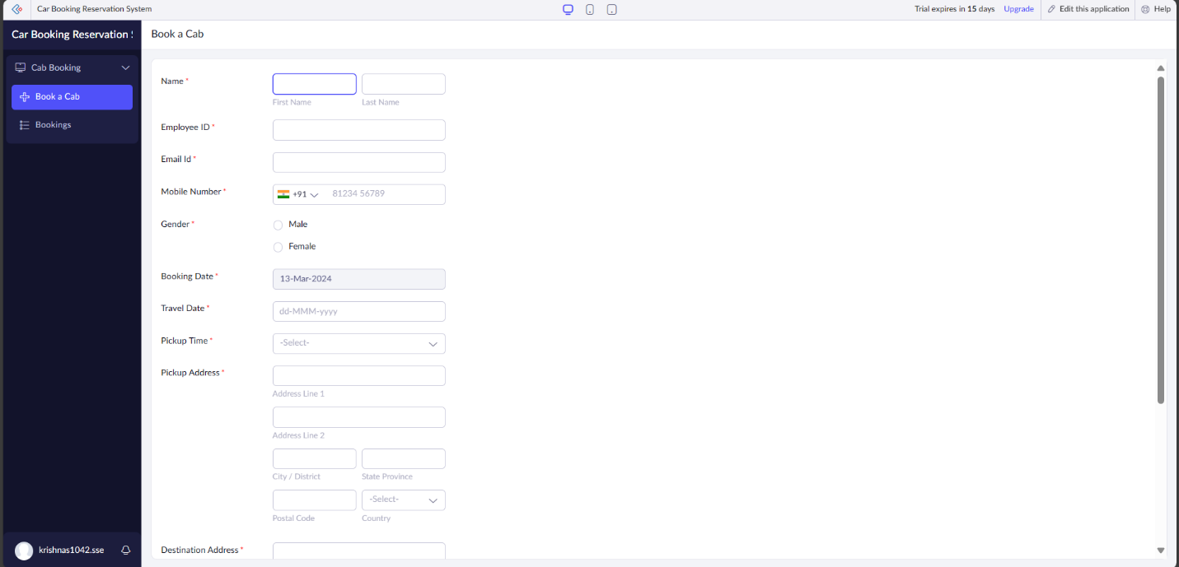

Steps:

* Sign up for a Cloud Service Provider
* Create a New Application Environment: Set up a new environment for your application within the chosen cloud service provider's platform.
* Design Your Application:
* User Authentication: Implement user authentication and authorization to ensure security.
* Main Dashboard: Create a dashboard for users to navigate through different functionalities.
* Car Search and Booking:
* Pickup location and drop-off location.
* Rental type (hourly, daily, outstation).
* Package type (e.g., standard, premium, luxury).
* Duration (number of hours or days).
* Car Availability Display: Show available cars based on the search criteria.
* Booking Confirmation:
* Payment Integration
* Set Up Database
* Implement Business Logic
* Deployment

Exp 4:

Library book reservation system

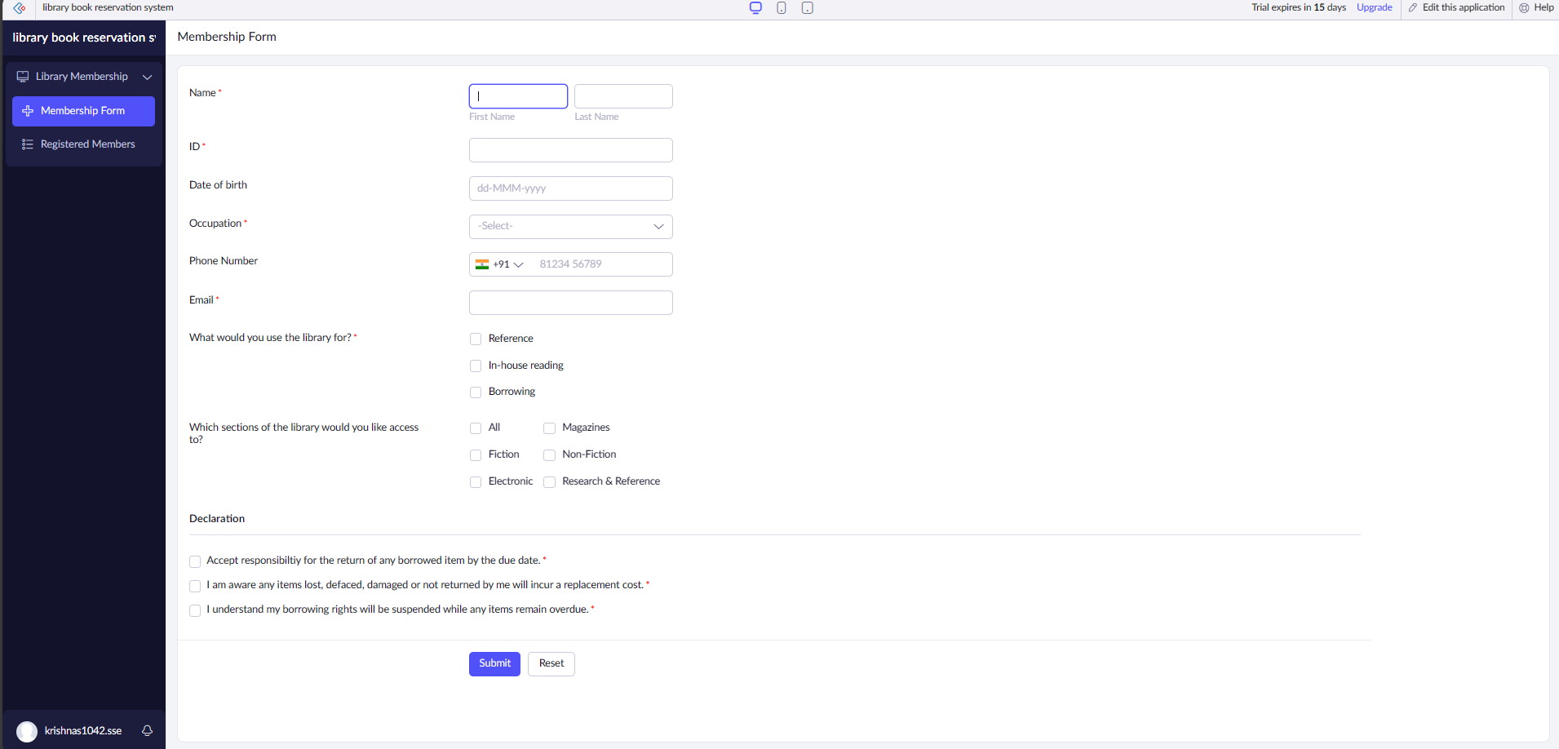

Steps:

* Sign up for a Cloud Service Provider: Choose a cloud service provider such as Amazon Web Services (AWS), Microsoft Azure, or Google Cloud Platform (GCP), and sign up for an account.
* Create a New Application Environment: Set up a new environment for your application within the chosen cloud service provider's platform.
* Design Your Application:
* User Authentication: Implement user authentication and authorization to ensure security.
* Main Dashboard: Create a dashboard for users to navigate through different functionalities.
* Book Search and Reservation:
* Title of the book.
* Author(s).
* Publication information (publisher, publication date).
* Year of publication.
* Edition.
* Number of copies available.
* Rack number (shelf location).
* Status (whether the book is available, taken, or returned).
* Book Reservation: Allow users to reserve books if they are available.
* Book Return: Enable users to mark books as returned after they have been borrowed.
* Implement Business Logic: Develop the backend logic to handle book searches, reservations, returns, user authentication, etc.
* Deployment

Exp 5

Mark Sheet Processing System

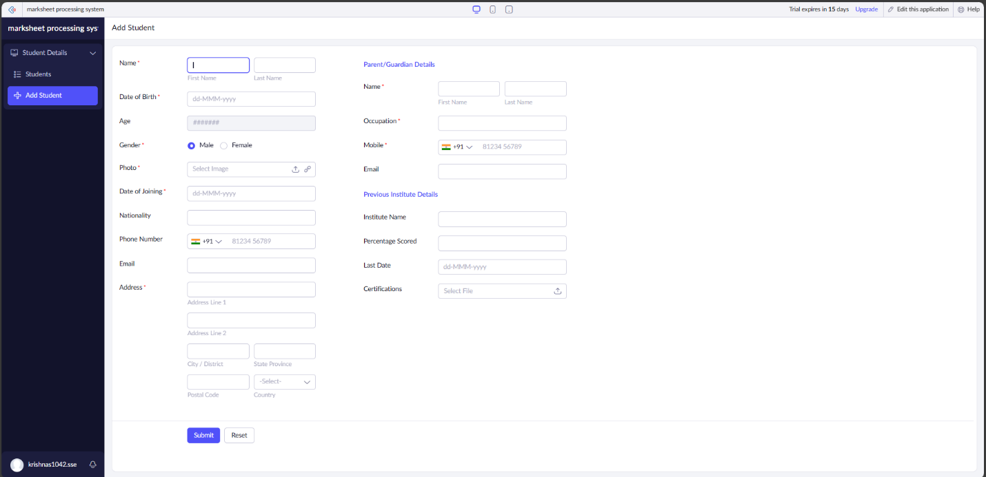

Steps:

* Sign up for a Cloud Service Provider
* Create a New Application Environment
* Design Your Application
* User Authentication: Implement user authentication and authorization to ensure security.
* Main Dashboard: Create a dashboard for users to navigate through different functionalities.
* Student Information:
* Name of the student.
* Registration number of the student.
* Subject-wise Marks:
* List of subjects.
* Marks obtained by the student in each subject.
* Calculated Fields:
* Average marks.
* Percentage.
* Rank (if applicable).
* Overall Performance:
* Summary or analysis of the student's performance.
* Set Up Database: Use a managed database service provided by your cloud service provider to store student data, mark details, calculated fields, etc
* Testing
* Deployment

Exp 6

Product selling

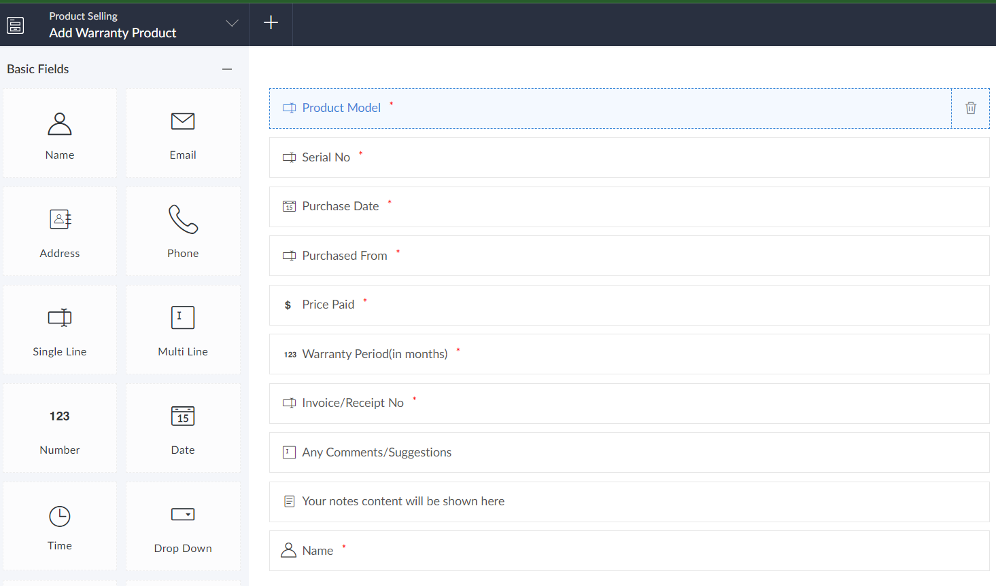

Steps:

* Choose Cloud Service Provider: Select a cloud service provider like AWS, Azure, or Google Cloud for hosting your application.
* Set Up Infrastructure: Use services like AWS Elastic Beanstalk for hosting your application, and MongoDB Atlas for the database.
* Develop Backend
* Use Node.js with Express.js for building the backend.
* Implement RESTful APIs for CRUD operations on products, user authentication, and order management.
* Utilize JSON Web Tokens (JWT) for authentication.
* Develop Frontend
* Use React.js for building the frontend.
* Design user interfaces for browsing products, viewing cart, and checkout.
* Implement frontend functionality to interact with backend APIs.
* Implement Authentication
* Enable user authentication using JWT.
* Allow users to sign up, log in, and log out securely.
* Test Application
* Perform thorough testing of frontend and backend functionalities.
* Ensure proper handling of edge cases and errors.
* Deploy to Cloud
* Deploy your application to AWS Elastic Beanstalk.
* Configure environment variables for database connection, JWT secret, etc.
* Monitor and Scale
* Set up monitoring and logging for your application.
* Configure auto-scaling to handle increased traffic efficiently.
* Maintenance and Updates

Exp 7

VM image

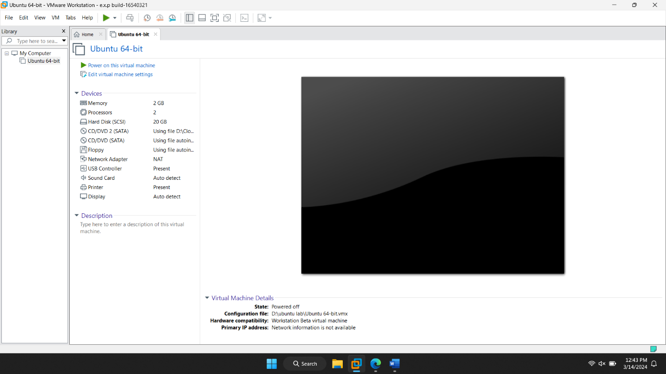

Steps:

* Install VirtualBox:
* Go to the VirtualBox website and download the installer suitable for your operating system.
* Follow the installation instructions provided by VirtualBox for your specific operating system.
* Download Host Operating System ISO:
* Depending on your preference, choose either a Windows ISO or a Linux ISO to install as the host operating system.
* You can obtain Windows ISO from the Microsoft website or a Linux distribution such as Ubuntu from their respective official websites.
* Create a Virtual Machine:
* Open VirtualBox after installation.
* Click on the "New" button to create a new virtual machine.
* Follow the wizard:
* Give your VM a name.
* Choose the type and version of the operating system you'll be installing (Windows or Linux).
* Allocate memory (RAM) for the VM.
* Create a virtual hard disk or use an existing one.
* Configure VM Settings:
* Before starting the VM, configure settings like:
* Processor cores.
* Network settings (NAT, Bridged, etc.).
* Shared folders (to access files between host and guest OS).
* Display settings (graphics memory, scale factor, etc.).
* Install Host Operating System:
* Start the VM.
* Follow the installation process of the chosen operating system.
* Test and Experiment:
* Snapshot and Backup (Optional):
* Take snapshots of your VM at different stages to revert to a previous state if needed.
* Regularly backup VM files to ensure data safety.

Exp 8

VM with cpu ram and storage

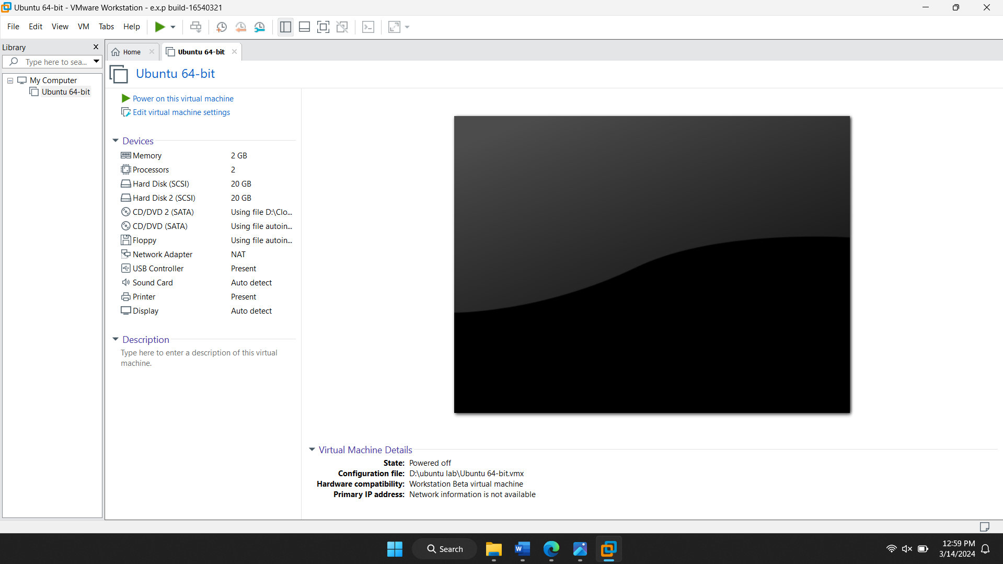

Steps:

* Install VirtualBox:
* Download and install VirtualBox from the VirtualBox website.
* Follow the installation instructions for your operating system.
* Launch VirtualBox:
* Open VirtualBox after installation.
* Create a New Virtual Machine:
* Click on the "New" button in the VirtualBox Manager window to create a new virtual machine.
* Configure Virtual Machine Settings:
* In the "Create Virtual Machine" wizard:
* Enter a name for your virtual machine (e.g., "MyVM").
* Choose the type and version of the operating system you'll be installing (e.g., Linux and the version you plan to use).
* Click "Next".
* Assign Memory (RAM):
* Create a Virtual Hard Disk:
* In the "Hard disk" section, select "Create a virtual hard disk now" and click "Create".
* Choose the disk file type (usually VDI for VirtualBox) and click "Next".
* Select "Dynamically allocated" for storage allocation.
* Set the size of the virtual hard disk to 15GB.
* Click "Create".
* Customize Additional Settings (Optional):
* Select the newly created virtual machine from the VirtualBox Manager.
* Click on "Settings" to customize additional settings such as CPU, display, network, etc.
* In the "System" tab, you can adjust the number of CPUs if needed. Set it to 1 CPU.
* Review and adjust other settings as per your requirements.
* Click "OK" to save the settings.
* Install Guest Operating System:
* Start the virtual machine by clicking "Start" in the VirtualBox Manager.
* Follow the prompts to install the guest operating system (e.g., boot from ISO image or installation media).
* Complete Installation:
* Start Using Your Virtual Machine:
* Once the guest operating system is installed, you can start using your virtual machine with the specified configuration.

Exp 9

Virtual hard disk

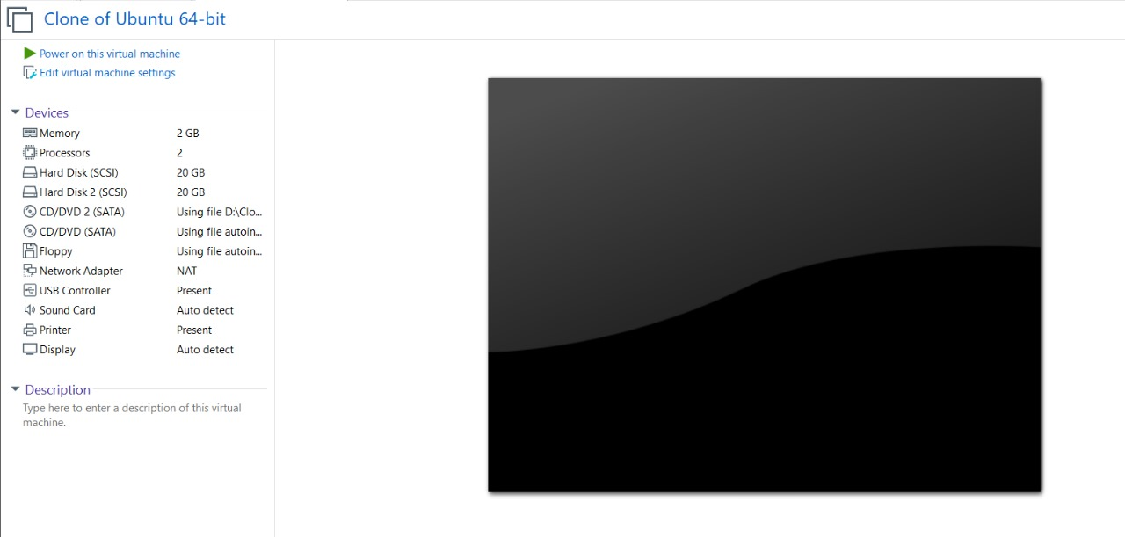

Steps:

* Open VMware Workstation:
* Launch VMware Workstation on your computer.
* Create a New Virtual Machine:
* Click on "File" in the menu bar and select "New Virtual Machine" to start the virtual machine creation wizard.
* Choose Custom (Advanced) Configuration:
* In the New Virtual Machine Wizard, select "Custom (advanced)" and click "Next".
* Specify Hardware Compatibility:
* Choose the hardware compatibility for your virtual machine and click "Next".
* Select Guest Operating System:
* Choose the guest operating system you'll be installing on the virtual machine and click "Next".
* Name the Virtual Machine:
* Enter a name for your virtual machine and choose the location where you want to store it. Click "Next".
* Customize Hardware:
* In the "Specify Disk Capacity" step, select "Create a new virtual disk" and click "Next".
* Specify Disk Type:
* Choose the type of virtual disk you want to create (e.g., SCSI, SATA, IDE) and click "Next".
* Allocate Disk Space:
* Enter the maximum disk size for your virtual hard disk. This determines the maximum amount of storage that the virtual disk can use on your physical disk.
* Choose whether to allocate all disk space now or allow it to grow as needed. Selecting "Allocate all disk space now" will pre-allocate the maximum disk size immediately.
* Click "Next".
* Customize Disk File Location:
* Choose the location where you want to store the virtual disk file (.vmdk).
* Optionally, you can change the disk file name.
* Click "Next".
* Review the settings you've configured for the virtual hard disk.
* Click "Finish" to create the virtual hard disk.
* Complete Virtual Machine Creation:
* Continue with the rest of the virtual machine creation wizard, specifying hardware settings like CPU, memory, network, etc.
* Once the virtual machine creation is complete, you can start the virtual machine and install the guest operating system.

Exp 10

Snapshot of VM

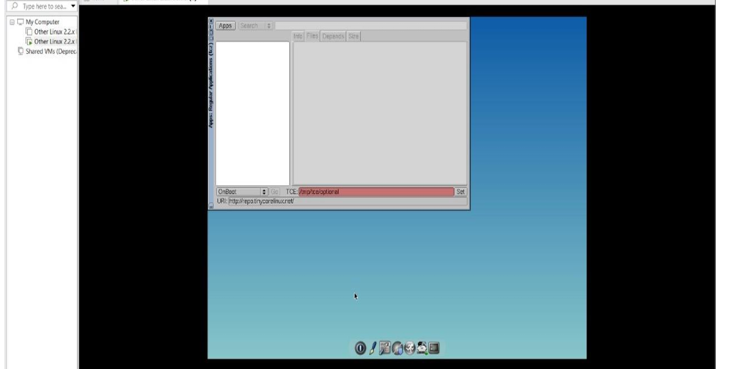

Steps:

* 1. Open VMware Workstation:
* Launch VMware Workstation on your computer.
* 2. Select the Virtual Machine:
* In the VMware Workstation interface, select the virtual machine for which you want to create a snapshot.
* 3. Take a Snapshot:
* Click on the "Snapshot" dropdown menu in the toolbar.
* Select "Take Snapshot" to create a snapshot of the current state of the virtual machine.
* Optionally, you can enter a name and description for the snapshot to help identify it later.
* Click "Take Snapshot" to confirm and create the snapshot.
* 4. Test Snapshot:
* Once the snapshot is created, you can test it by loading the previous version of the virtual machine.
* To do this, close any running virtual machines associated with the snapshot.
* Right-click on the virtual machine in the VMware Workstation interface and select "Manage Snapshots".
* In the "Snapshot Manager" window, you'll see a list of snapshots. Select the snapshot you want to revert to.
* Click on the "Go To" button to load the virtual machine with the selected snapshot.
* 5. Verify:
* Once the virtual machine is loaded with the selected snapshot, verify that it has reverted to the desired state.
* Test any functionalities or configurations that you want to verify in the previous version of the virtual machine.
* 6. Clone Virtual Machine (Optional):
* If you want to test the snapshot without altering the original virtual machine, you can clone it.
* Right-click on the virtual machine in the VMware Workstation interface and select "Clone".
* Follow the prompts to create a clone of the virtual machine.
* Once the clone is created, you can test the snapshot on the cloned virtual machine without affecting the original.
* 7. Revert or Delete Snapshot (Optional):
* After testing the snapshot, you can choose to revert to the original state or delete the snapshot.
* If you want to revert to the original state, simply load the latest snapshot or the original virtual machine.
* To delete a snapshot, right-click on it in the "Snapshot Manager" window and select "Delete".
* Confirm the deletion if prompted.

Exp 11

Cloning of VM

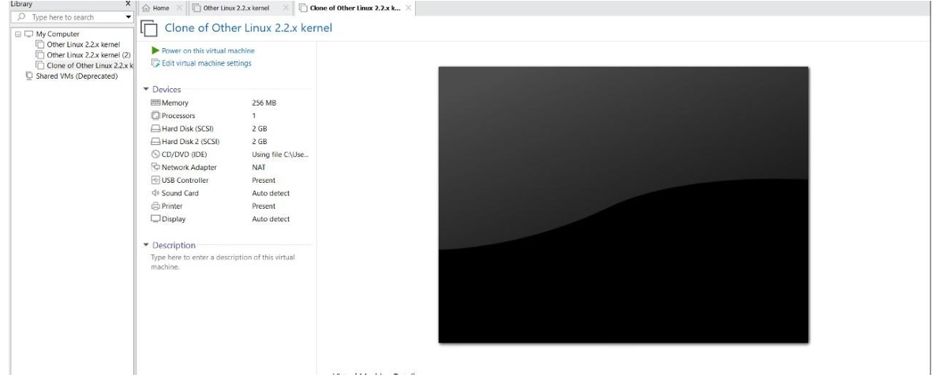

Steps:

* 1. Open VMware Workstation:
* Launch VMware Workstation on your computer.
* 2. Select the Virtual Machine:
* In the VMware Workstation interface, select the virtual machine you want to clone.
* 3. Clone the Virtual Machine:
* Right-click on the selected virtual machine and choose "Clone".
* Alternatively, you can go to the "VM" menu, select "Manage" and then "Clone".
* Follow the prompts in the Clone Virtual Machine Wizard.
* 4. Customize Clone Settings (Optional):
* In the Clone Virtual Machine Wizard, you can choose whether to create a linked clone or a full clone.
* Linked clones share virtual disks with the parent VM, conserving disk space.
* Full clones have separate virtual disks, allowing independent operation.
* Choose the appropriate option based on your requirements and click "Next".
* 5. Specify Name and Location:
* Enter a name for the cloned virtual machine and choose the location where you want to store it.
* Click "Next" to continue.
* 6. Customize Hardware (Optional):
* Optionally, you can customize hardware settings such as CPU, memory, network, etc., for the cloned virtual machine.
* Click "Next" to proceed.
* 7. Clone the Virtual Machine:
* Review the settings you've configured for the clone and click "Finish" to create the clone.
* VMware Workstation will begin the cloning process.
* 8. Test the Cloned Virtual Machine:
* Once the cloning process is complete, you can test the cloned virtual machine by loading it.
* Close any running virtual machines associated with the original or cloned VM.
* Find the cloned virtual machine in the VMware Workstation interface.
* Double-click on the cloned virtual machine to start it.
* 9. Verify:
* Once the cloned virtual machine is loaded, verify that it functions as expected.
* Test any functionalities or configurations that you want to verify in the cloned VM.
* 10. Revert or Delete the Cloned Virtual Machine (Optional):
* After testing the cloned virtual machine, you can choose to revert to the original state or delete the clone.
* To revert to the original state, simply load the original virtual machine.
* To delete the cloned virtual machine, right-click on it in the VMware Workstation interface and select "Delete from Disk".

Exp 12

Change hardware compatibility of VM

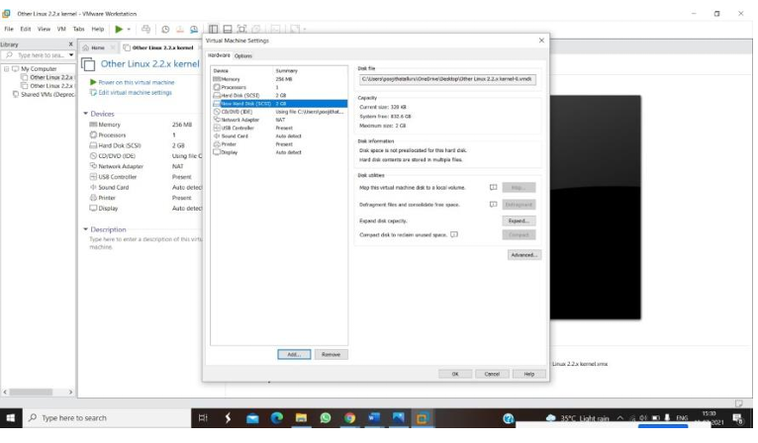

Steps:

* 1. Open VMware Workstation:
* Launch VMware Workstation on your computer.
* 2. Select the Virtual Machine:
* In the VMware Workstation interface, select the virtual machine for which you want to change the hardware compatibility.
* 3. Shut Down the Virtual Machine:
* If the virtual machine is running, shut it down gracefully by selecting "Power" > "Shut Down Guest".
* 4. Create a Snapshot (Optional):
* Before making significant changes, it's a good idea to take a snapshot of the virtual machine to create a restore point.
* Right-click on the virtual machine and select "Snapshot" > "Take Snapshot".
* Enter a name and description for the snapshot to help identify it later, then click "Take Snapshot".
* 5. Change Hardware Compatibility:
* 6. Choose New Compatibility Level:
* In the Change Hardware Compatibility wizard, you'll see a list of compatibility levels.
* Select the compatibility level that you want to change to. Typically, you'll want to choose the latest available compatibility level to take advantage of new features and enhancements.
* Click "Next" to continue.
* 7. Review and Confirm:
* Review the summary of changes that will occur when changing the hardware compatibility level.
* Ensure that you understand the implications of changing the compatibility level.
* Click "Finish" to apply the changes.
* 8. Start the Virtual Machine:
* Once the hardware compatibility is changed, start the virtual machine to verify that it boots up without issues.
* Test any functionalities or configurations to ensure that everything works as expected.
* 9. Revert to Snapshot (If Necessary):
* If you encounter any issues or want to revert to the previous state, you can revert to the snapshot taken earlier.
* Right-click on the virtual machine, select "Manage" > "Revert to Snapshot", and choose the snapshot you created earlier.
* Follow the prompts to revert to the snapshot.

Exp 13

Creating a virtual machine using public cloud services in Microsoft Azure.

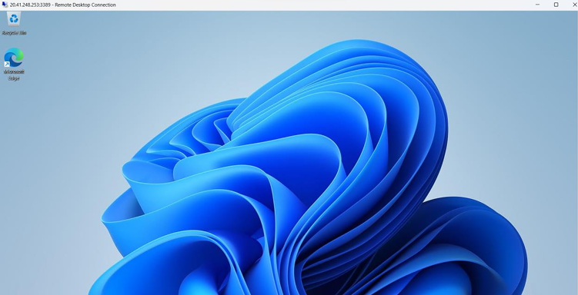

Steps:

* create an account in Microsoft azure.
* Go to resource group and create a resource group.
* give necessary things for resource group.
* create a virtual network for to create a virtual machine.
* now create a virtual machine with ur ip address an username and password for your virtual machine.
* and your virtual machine is deployed.
* now connect the virtual machine and download the rdp file to open your windows virtual machine.
* now resize the virtual machine size.
* created a new windows virtual machine

Exp 14

Demonstrate infrastructure as a service

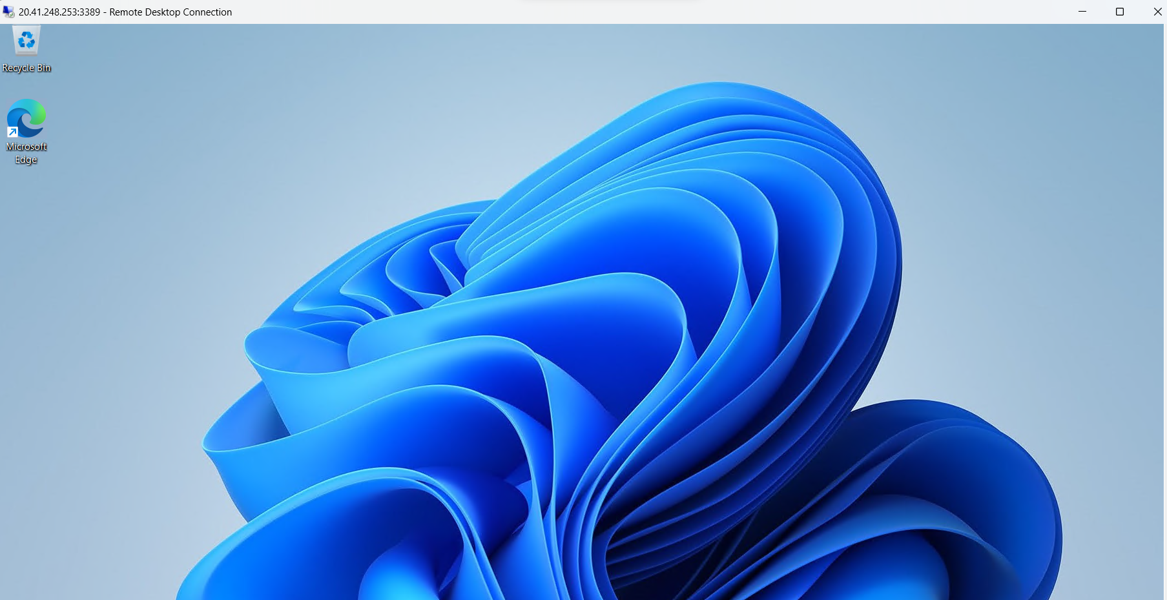

Steps:

* create an account in Microsoft azure.
* Go to resource group and create a resource group.
* give necessary things for resource group.
* create a virtual network for to create a virtual machine.
* now create a virtual machine with ur ip address an username and password for your virtual machine.
* and your virtual machine is deployed.
* now connect the virtual machine and download the rdp file to open your windows virtual machine.
* now resize the virtual machine size.
* created a new windows virtual machine

Exp 15

Creating a simple website using azure

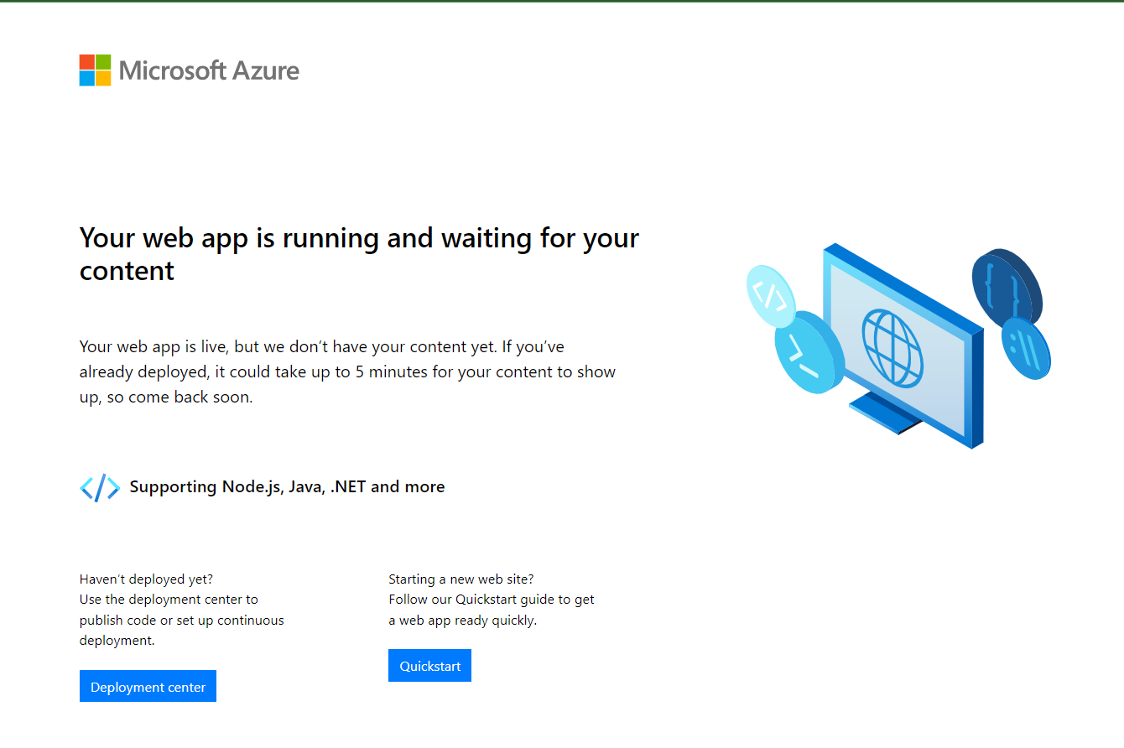

Steps:

* firstly, go to app service to create an webapp.
* enter the resource group and webapp name and region and select the Linux os.
* after enter the all the necessary things click there view and create and click the create the web app.

Exp 16

demonstrate infrastructure as a service(iaas) provider(azure) configure with minimum cpu, ram and storage and launch the vm image.



Steps:

* create an account in microsoft azure.
* Go to resource group and create a resource group.
* give necessary things for resource group.
* create a virtual network for to create a virtual machine.
* now create a virtual machine with ur ip address and username and password for your virtual machine.
* and your virtual machine is deployed.
* now connect the virtual machine and download the rdp file to open your windows virtual machine.
* created a new windows virtual machine

Exp 17

create a storage service using any public cloud service provider (azure/gcp/aws) and check the public accessibility of the stored file to demonstrate storage as a service

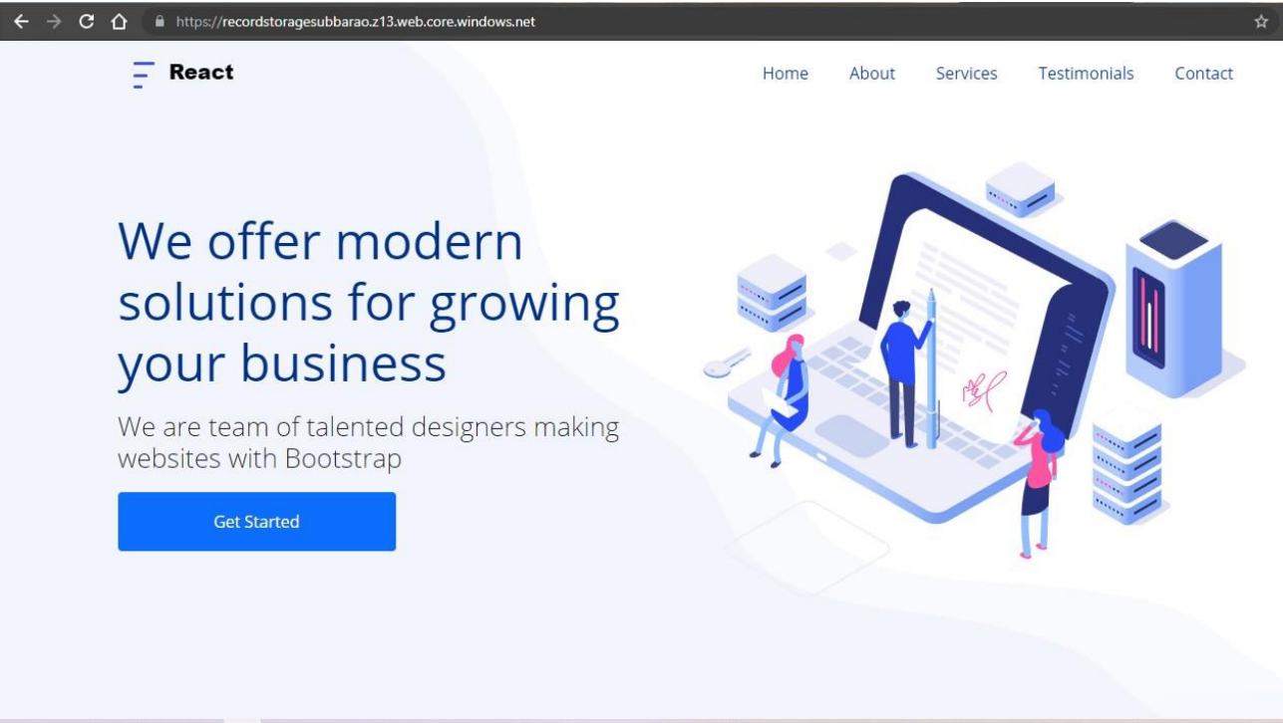

Steps:

* open azure and go to storage accounts and create storage account
* enter the resource group and and storage account name and review and create and click th create and your storage account will be deployed sucessfully.
* our storage account is created. step4: goto static website
* and enable and enter your index and error html files names.
* and go to storage explore(review) and and go to blob containers and web and upload the two html files in it
* and again, return to static website and open the primary link and your web page is created.

Exp 18

create a sql storage service and perform a basic query using any public cloud service provider (azure/gcp/aws) to demonstrate database as a service (daas).

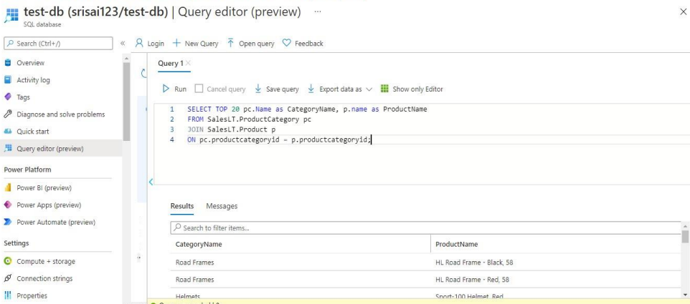

Steps:

* go to azure and go to sql database.
* now create a sql databse
* select the resource group and enter the server name that is applicable.
* in networking select allow azure services and resources to access this server.
* in additional settings select sample.
* and the sql database is deployed
* now go to query editor.
* Now again login to the sql data database
* our tables will shown and type the query to executed